September XX, 2016
Hon. Members of the City Council via email
City Hall 600 Fourth Ave. 2nd Floor
Seattle, WA 98104
Dear Council Members and Staff
The CNC Neighborhood Planning and Land Use Committee (CNC NPLUC) formed a “reading” subcommittee to review and comment on the Draft Comprehensive Plan Seattle 2035 when it was released in July, 2015. Our 53-page comment letter was submitted in November, 2015. The reading group, with additional members, subsequently reviewed the Mayor’s Recommended Plan in a series of open meetings beginning in May 2016.
We elected to focus this letter on only the most critical issues we have with the Mayor’s Draft Plan, although most of the comments in our November letter remain valid. It is our hope and expectation that the City Council will consider our comments and propose amendments that reflect the opinions and concerns of Seattle citizens. The comments in this letter reflect the consensus of our committee and the opinions expressed by many other citizens in gatherings, social media, and on-line correspondence over the last few months.
We will begin with a summary of our most pressing concerns followed by a discussion of those issues that have been flagged for your attention by Council Central Staff in their August 10, 2016 Memorandum to the PLUZ Committee. This letter will not comment on every technical amendment in the memo; we will highlight those where we have strong agreement or disagreement. The abbreviation CCS will refer to the August 10th memo. The remaining pages of this document contain more detailed comments on most aspects of the Mayor’s Plan from CNC NPLUC committee members.

SUMMARY OF MAJOR CONCERNS AND RECOMMENDATIONS

1. Restore the Important Role of Neighborhood Plans, Goals and Policies
The Mayor’s Plan significantly diminishes the value of local, citizen planning and thus the value of citizen engagement in fundamental areas of land use planning, growth management and capital investment. The policies in the Mayor’s Plan should be amended to clarify that Neighborhood Plans, Goals and Policies take priority over general Comprehensive Plan goals when decisions such as rezones, development standards and design guidelines changes are proposed. Neighborhood planning provides flexibility and diversity in applying citywide regulations to accommodate growth while respecting individual neighborhood characteristics. Restore the following policies from the current plan: N2 – Resolving inconsistencies between Neighborhood Plans and the Comprehensive Plan; N7 – Guidelines for Neighborhood Plans; NG2 – Involve all community members; NG4 – define role of plans with update to assure compliance with adopted plans.
Add policies that clarify the relationship of Urban Design Framework (UDF) and Action Plans to Neighborhood Plans and set enforceable criteria for updating all forms of neighborhood plans through the life of Seattle 2035. Policies should ensure adequate funding for systematic review and updating of neighborhood plans to keep up with physical and demographic changes. Over 40% of the neighborhood plans adopted since 1994 have not been updated. The new Planning Department should have an official neighborhood plan ombudsman to track how Department level functional planning is consistent with Neighborhood plan goals. Restore policies concerning regular monitoring, measuring and the actions to be taken when growth is occurring below or above the expectations of the Comp Plan. See more detail below.

2. Wishful Thinking Is Not a Substitute for Concurrency.
We may wish that most people in Seattle could walk, bike or take transit to work and for their routine chores but that is not reality and it will never be in our city of hills, bridges, water bodies and rain. Diversity considerations such as age and family size should be recognized. The goals and policies of the Comprehensive Plan should not reflect only image of young tech workers. Over time more people may drive electric cars and more fuel efficient cars, but they will drive personal vehicles and they will need to park them at both ends of every trip. The Mayor’s Plan tries to paper over these truths with silly infographics. An increase in bike and transit ridership is a good thing however, overall population and job growth will swamp any gains thus made. Transportation problems and livability will only become worse. We need realistic policies about the priority use of the public streets for the majority modes. We need policies that recognize that on street parking is the lifeblood of neighborhood commercial districts and most multi-family zones areas. We need policies that direct development of transit level of service standards that don’t leave hundreds of people behind at bus stops and the rest feeling like they’re in a Tokyo train!
Specifically reject the unworkable proposal to redefine our arterial level of service standard as a percentage of SOV vehicles.
Require staff to provide an estimate of future transit demand that is consistent with growth estimates in Growth Srategy Figure 2 (as revised with numeric estimates). Policies eliminating the requirement of off-street parking in areas with transit service should be reconsidered in light of these findings. The Growth Strategy Element is dependent on having adequate transit but the plan gives you no idea if there is or will be adequate service.
The Mayors Plan goal LU G6 calls for parking to be regulated to limit construction cost. The current policy it replaces (LUG4) focused on managing parking to reduce housing cost. Restore LUG4 which better links the benefit of housing affordability to the loss of parking. Merely reducing construction cost chiefly benefits the developer, not the renter.
We recommend policies favoring direct impact fees when employers suddenly import hundreds or thousands of workers into already congested areas creating major transportation impacts and costs.

3. Maintain the Urban Village Growth Strategy and Clear Land Use Zone Distinctions
The Mayor’s Plan (and some of the Planning Commission’s recommendations) seek to undermine this agreed on approach by redefining urban village boundaries based on theoretical 10-minute transit walksheds and defining growth areas in terms of transit corridors rather than the existing urban village boundaries and nodes. Do not modify the Future Land Use Map as proposed and reject LU 1.5. Require better policy direction for managing growth outside of urban centers and villages. Revise GS 2.19 Allow limited Limit multifamily, commercial, and industrial uses outside of urban villages to support the surrounding area or to maintain the existing character. Retain the rezone policy language in the current plan (LU1, LU3 and LU5).

4. Protect the Housing Choice in Single Family Zones & Save Remaining Large Trees
The Mayor’s Plan includes many references to the need for affordable, family-sized housing options. This need is best met in the great diversity of single family zoned neighborhoods in Seattle. Yet the Mayor’s Plan seeks to erode those very housing choices by eliminating the historic policies protecting single family zones from inappropriate and exploitative development schemes. We urge you to resist this unnecessary change and restore the current plan policies LUG8, LUG9, LUG10, LU59 and LU60. Do not accept the Mayor’s substitute policies (LU G7). The Planning Commission is getting well ahead of the majority public opinion in their ongoing effort to “pick the lock” (their term) on single family zones. We urge you not to make this mistake. The relaxation of standards will not result in the densification of neighborhoods with 7,500 and 10,000 single family lots. It will put terrific strain on neighborhoods with the last remaining stock of lower cost, detached housing with places for children to safely play in a backyard. It will undermine tree preservation goals which are already suffering under the relentless redevelopment of single family and lowrise zones throughout the city.

5. Make Community Engagement an Element in the Comprehensive Plan.
The goals and policies underlying the process of seeking, receiving and responding to citizens input into both legislative and administrative decisions warrants a separate chapter in the Plan. The Growth Management Act also places emphasis on community participation in all actions related to GMA compliance.

TABLE OF CONTENTS
SUMMARY OF MAJOR CONCERNS AND RECOMMENDATIONS 1
AMENDMENTS IN AUG. 10th STAFF MEMO 4
A SEPARATE COMMUNITY ENGAGEMENT ELEMENT 4
GROWTH STRATEGY ELEMENT -POLICIES 4
LAND USE ELEMENT - POLICIES 5
TRANSPORTATION ELEMENT – POLICIES 7
HOUSING ELEMENT – POLICIES 9
CAPITAL FACILITIES 9
UTILITIES ELEMENT – POLICIES 9
ECONOMIC DEVELOPMENT ELEMENT – POLICIES 9
ENVIRONMENT ELEMENT – POLICIES 9
PARKS AND OPEN SPACE ELEMENT – POLICIES 9
ARTS AND CULTURE ELEMENT – POLICIES 10
COMMUNITY WELLBEING ELEMENT – POLICIES 10
NEIGHBORHOOD PLANNING ELEMENT - POLICIES 11
ADDITIONAL COMMENTS ON MAYOR’S PLAN BY TOPIC 12
DETATCHED HOUSING – INSIDE/OUTSIDE URBAN VILLAGES/TRANSIT CORRIDORS 12
FLUM AND NEIGHBORHOOD PLANNING RESTORE ROLE OF NEIGHBORHOOD PLANS IN LAND USE REGULATIONS 14
PERSONAL TRANSPORTATION, ACCESS AND EQUITY 17
SUPPORTING GROWTH – TRANSIT, TRANSPORTATION, UTILITIES, PARKS, SCHOOLS (CONCURRENCY) 18
GROWTH ESTIMATES/METRICS 19
PARKS LEVEL OF SERVICES 21
TREE PRESERVATION, CANOPY AND DIVERSITY OF TREES IN THE CITY 22
SURPLUS PROPERTY PRIORITIES 22
HOUSING 23
References 24

AMENDMENTS IN AUG. 10th STAFF MEMO

A SEPARATE COMMUNITY ENGAGEMENT ELEMENT
We strongly support the potential amendments 1a. and 1b. to create a separate element and “add policies to better reflect the city’s approach to engagement across departments and issues.” GS 1, GS 1.1-GS 1.10 are not sufficient to address all policy objectives for community engagement. This is particularly true now that the Mayor has abandoned the District Council system without proposing any meaningful alternative. We do not agree with 1c. The Neighborhood Planning element should be retained as a separate element. While community engagement is an important aspect of neighborhood planning, there are many other relevant goals and policies related to neighborhood planning.
The existing draft of the 2035 Comprehensive Plan touches in multiple places the topic of engagement with Seattle residents, businesses, and marginalized populations – in other words, all citizens. Yet the language used varies across the elements. Sometimes it’s just a broad cross section, sometimes it’s all people. And the policies suggested also focus on the element topic, not so much the quality or results of the engagement.
We suggest that a new Community Engagement Element describes how people should be involved in the decisions and what the expectation of quality engagement looks like.
Suggested goal topics:
- Community involvement as a partnership
- Accessible, meaningful and effective participation
- Involvement of people of all ages, abilities and economic conditions
- Capacity building for civic engagement.
- Membership on official city advisory bodies
- Restoring citizen stewardship committees for neighborhood plans

Policies should be created to address:
- Transparency
- Ease of access to information to facilitate participation
- Ample, early, timely and adequate notice of opportunities to participate
- Accountability and responsiveness
- Social equity, including environmental justice
- Implement lessons from the 2004- 2014 Comprehensive Plan
- Implement quality of life and concurrency metrics for use in involvement
- Promote and reward civic responsibility
- Build Departmental capacity to facilitate community involvement

GROWTH STRATEGY ELEMENT -POLICIES
CCS Item 16. In Growth Strategy Figure 3, rather than increasing the percentage “rates” for high opportunity and decreasing them for low opportunity areas, we recommend restoring specific target numbers for every urban village. The Growth Strategy Element should include the Attachment 1 Tables A and B from the June 2, 2016 Central Staff Memo to the PLUZ Committee that show meaningful estimates of housing and job growth. However that table should be incorporated into the body of the document for ease of reference and visibility. It could replace the current Growth Strategy Figure 3 -Estimated Urban Village Growth Rates (percentages) which is uninformative and confusing.
The entire high and low opportunity area concept is a bit puzzling and will result in unintended consequences. Rather than try to shift populations into so called high opportunity areas by increasing the growth targets in those area, the goal should be to improve, and enhance the low opportunity areas. People should not have to leave their historic neighborhood to live near a grocery store! More jobs should be created in areas where opportunity is lacking. In fact this appears to be the focus of CCS Item 24. GS1.5 (particularly with the addition of the word equity) since city investment is often used to leverage private investment.
CCS Item 17. Do not add the language recommended by the Planning Commission which amounts to a contradiction in the Urban Village strategy by promoting growth along transit corridors outside of urban villages. The statement they recommend is unnecessary since growth is already occurring along these corridors per zoned capacity and Comp Plan policies anticipating some growth outside urban villages. Merely being on a bus or rail line does not predict access to the referenced “essential components of livability.”

Technical Amendments
CCS Items 6, 7, 10. We agree with strengthen language for key indicators and adding number of demolished housing units to the key indicators.
CCS Item 25. Do not strike the phrase “open space” since planning for open space is as important as planning for parks and recreation. They are not the same and both are needed by people living in increasingly dense neighborhoods.
CCS Item 26. Concerning GS 2.12, we agree that industrial zones should be excluded from urban village boundaries but we do not agree in general with the loose “ten minute walk from very good bus service” criteria for defining a boundary condition for a mapped urban village. Very good bus service is not defined and a 10 minute walk is highly variable depending on topography, weather and physical abilities. The logical extension of this policy would be a transit corridor strategy, not an urban village strategy. Land use policy should not be made by Metro or subject to its changing levels of service.
CCS Item 29. We agree with adding new policy GS 3.6 – policy about support for slow-growing areas.
CCS Item 31, 32. See Item CCS 16 above. We agree with adding growth estimates but we do not agree with burying this information in the Appendix. This should be in the Plan.
CCS Item 34. We wholeheartedly agree with this recommendation to add a strong policy on tree preservation and canopy expansion.

LAND USE ELEMENT - POLICIES
CCS Item 35. We support the a. alternative to provide more specific guidance using understandable terms such as height, and measure of scale and lot occupancy that is more comprehensible than FAR, as a means of explaining the difference between low, moderate and high density scale to distinguish between urban village types. We do not support c. alternative allowing more density near “light rail and frequent bus service” until we adopt a more comprehensive definition of bus and transit level of service that includes the actual ability to ride comfortably, not just being crammed in like sardines. Any linkage to upzoning or other ways of increasing density based on the proximity to transit must be based on local performance, not just listed headways.
CCS Item 36. We agree with items a. b. and d. FLUM changes are premature for the reasons given by staff. Blurring the zone distinctions within urban villages will create confusion. In a city with mature zone designations, changing zoning should be a well-considered process where the general public in an area has sufficient opportunity to be informed. Changing the FLUM to expedite rezones is contrary to the goals of Community Engagement and Neighborhood Planning.
CCS Item 37. We agree with the Planning Commission recommendation to adopt the stronger policies on retaining industrial land in MICs and discouraging creeping office uses in I/C zones inside MICs. (LU11.22 in the draft plan.) We support option b. Adopt language in the 2015 draft plan regarding industrial lands.
CCS Item 38. We strongly disagree with the Planning Commission’s expansionist tendencies. The zoning capacity exists to accommodate growth without changing the definition and use standards for single family zones. We certainly reject the replacement of “inside” urban villages with “near urban village” in this policy. We agree with option b. Delete LU 7.3 entirely.
LU 7.3 Consider allowing redevelopment or infill development of single-family areas inside urban centers and villages, where new development would maintain the low height and bulk that characterize the single-family area, while allowing a wider range of housing types.

Technical Amendments
CCS Item 39. The staff has recommended an addition to LU 3.2 “Consider providing greater flexibility for schools in recognition of their important role in the community.” Is the intent to limit this flexibility to public and private elementary and high schools or will it apply to all manner of private institutions that have any educational programming and call themselves schools? The latter could become troublesome if within or nearby a low density zone. This need to be clarified.
CCS Item 40. The staff has recommended adding more reasons to regulate off-street parking - “improve public health and safety, reduce greenhouse gas emission,” in addition to the already tenuous “lower construction cost, create attractive and walkable environmental and promote economic development throughout the city.” Our preference is to eliminate LU G6. This policy is misguided.
The policy instead should be to regulate off-street parking to meet the demonstrated need of each development considering the measured capacity and utilization of accessible nearby parking facilities and on street parking.
SDCI regularly allows MORE off-street parking in South Lake Union than the code maximums despite an abundance of nearby residential development, new bike lanes and transit service. Eliminating parking has the opposite effect in neighborhood commercial areas; it threatens the economic health of those areas, makes it less safe pedestrian because cars are circling endlessly hoping for a place to park because there is not enough off street parking to meet local residential and commercial need.
CCS Item 42. This concerns amending LU 6.10 to substitute “transportation” for “parking” in reference to transportation management programs and clarifies the intent is to apply various measure to manage transportation (mostly to reduce parking) by applying it to areas with “access to frequent transit.” It could be interpreted to mean any commercial or multifamily area within the troublesome 10 minute walkshed to some form of transit that may or may not meet King County’s definition of “frequent “ transit and may be well outside an urban village boundary. Should the council choose to retain this ambiguous policy, we recommend adding new ideas, car-free leases and mandatory share-car on-site parking spaces - to the list of transportation management options.
CCS Item 45. We do not support the recommendation to modify LU 7.2. The current language, to protect designated single family areas, is a different concept that “limiting development.” For this 20 year period, single family should be protected and held as a “land bank” until the next Comp Plan update, when more deliberate polices can be drafted about the transformation of single family zones should growth outpace the capacity of multi-family zoning.
CCS Item 46. The staff has recommended adding examples to LU 7.3. in underline below.
LU 7.3 Consider allowing redevelopment or infill development of single-family areas inside urban centers and villages, where new development would maintain the low height and bulk that characterize the single-family area, while allowing a wider range of housing types such as detached accessory units, cottage developments or small duplexes or triplexes.
Expressions like “small” can have different meaning to different people. This policy could open the door to changes in the lot coverage standards in single family zones, which is not desired, in order to accommodate these more dense housing types. On some large corner lots abutting an alley, replacing a single structure with a triplex built to 35-feet in height, may be acceptable but building that structure mid-block where it breaks up a pattern of smaller, older homes and potentially impacts neighbors on three sides would not be favored. The code already allows ADUs and DADUs and is considering expanding capacity for this use. This policy seems too broad. These types of changes should be handled in the context of a neighborhood plan.
CCS Item 47. Staff has recommended adding some language to LU 7.5 about lower income households. (underlined below). The policy already references a “broad range of households and incomes” making this addition redundant. The addition of the “family sized units” in association with accessory dwelling units is an odd juxtaposition. ADUs are rarely family-sized units. A better way to provide family-sized units for lower income households is to protect older single family housing stock, either as rentals or for purchase. That should be the policy direction.
LU 7.5 Encourage accessory dwelling units, family sized units, and other housing types that are attractive and affordable to a broad range of households and incomes, including lower income households, and that are compatible with development pattern and building scale in single-family areas.
CCS Item 49. This staff recommendation highlights a current problem and contains an oxymoron. LU 9.7 would allow more residential uses in neighborhood commercial areas and potentially other commercial areas at ground level. This could break up the continuity of commercial street fronts which is already a problem with many live-work units in NC zones. The policy includes this impossibility “…apply standards that give ground-floor tenants privacy and create visual interest along the street front.” The blinds drawn syndrome will prevail. The creative use of one way glass with murals painted on the outside will not. We do not support this policy.

TRANSPORTATION ELEMENT – POLICIES
CCS Item 52. We agree that the different terms use to describe transit throughout the plan are confusing or missing from the glossary. The plan’s glossary definition of high capacity transit is “ In Seattle, high-capacity transit consists of both rail and rubber-tired transit modes that can operate in exclusive rights-of-way or in mixed traffic. It can include technologies such as light rail or bus rapid transit.” This definition says nothing about capacity, such as how many riders can be served on a given route during peak hours. Frequent transit is defined as “Generally, bus or train service that arrives at intervals of fifteen minutes or less.” Very good bus service, is used in the Growth Strategies element but is not defined. “Very good transit service” is another terms used and defined in a footnote to Growth Strategy Figure 3.
We recommend consistently using the same terminology and operating characteristics used by King County Metro (KCM) since they provide the majority of transit service in Seattle. In the Metro Connects 2040 plan. The table below is from Technical Appendix A Service Network. The accompanying definition is: “Frequent service is defined as service with a frequency of every five to 15 minutes during weekdays, with a minimum frequency of every 15 minutes on weekends. In areas of highest demand, frequent service headways could be as low as every five minutes or better.”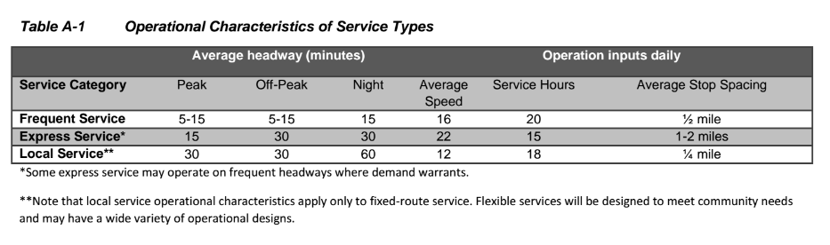
Metro Connects also include a list of routes that KCM defines as providing frequent service, many of which are in Seattle. We recommend including an excerpt from that list in the Seattle Comp Plan to further clarify where land use policies related to “frequent transit” could occur. This would be very helpful to better understand the growth rates percentages given in Growth Strategy Figure 3 (page 30) if that figure is retained or even if it is replaced as we recommended in CCS Item 16 discussion above.

OTHER POLICIES NOT ADDRESSED IN CCS MEMO

Do not adopt the proposed SOV reduction as a level of services standard.
T 9.1 New “efficiency” level of service recommendation are premature. The Council should postpone accepting this policy change. This is a new concept that was NOT described in the draft plan. Related policies concerning transportation spending priorities (TG 10)” to support the City’s transportation….and other goals” strongly implies that spending the Move Seattle Levy funds could be directed by the policy. This amounts to a bait and switch for the voters who were not made aware of this new definition of level of service as a substitute for the goal of “congestion relief.” Policy T 1.5 calls for investing transportation dollars into “projects and programs that further meeting the city’s mode share goals.” However related Transportation Figures 1 and 2 (showing work and nonwork mode share goals) are not supported by any explanation of how these goals were arrived at. This information is not included in the Appendix. The Council Central Staff in their June 15th 2016 memo to the Transportation and Sustainability Committee recommended against this policy: “Council may wish to wait to adopt new LOS standard policies until such time as the Executive transmits the implementing legislation so that a discussion can be had about how the new policies will be made operational, including an examination of any changes to development regulations and to the prioritization of Seattle’s transportation investments, and so that the policy and regulatory changes can be acted upon together.”
Roadway Pricing Policies Too Far Ahead of Public Awareness and Inconsistent with Social Justice Initiatives
New policy T 3.18 introduces the concept of “roadway pricing strategies.” This would be a major policy shift and not something that voters were aware was in the offing when the Move Seattle vote occurred. The policy as stated is too broad and could be applied to all arterials, not merely some in the Center City. We recommend deleting this policy until there has been a real public debate over the application and merits of this proposal. Use of the word “consider” in this sentence seems like an attempt to divert attention from the implications of this policy. Clearly there has been internal city analysis but the public has not been engaged on this concept. As one of our members put it, how does creating Lexus Lanes in Seattle advance the cause of social justice or make the city more affordable?

Technical Amendments
CCS Item 57. We do not agree that demand management strategies- which is code for removing parking - should be the top “tactic” to resolve conflicts for space in the right of way. It should remain the last in the list of tactics.
CCS Item 61. We agree with use of “Increase” versus enhance and recommend this further clarification to T 4.2 Increase the public street canopy and landscaping in the street right-of-way outside of travel and parking lanes.
CCS Item 62. Delete this policy. “T 4.4 Manage the transportation system to support modes that reduce the use of fossil fuels and promote the user of alternative fuels.” This policy invites discrimination against people who can’t afford to drive electric vehicles. How would this policy be implemented? There are other policies favoring bike lanes.
CCS Item 67. See discussion in CCS Item 42 to add car-free leases and mandatory on-site parking for share cars to the list of TDM tools in T 9.2.
CCS Item 68. Concerning policy T 9.3 we recommend adding the following: “Pursue strategies to reduce drive-alone trips, including those made by car-share users which are predominantly drive alone trips, in order to increase the ability of the city’s transportation network to carry people and goods.”
CCS Item 70. We do not support this new policy (T 10.11) which appears to seek ways to reduce maintenance costs at the expense of safety by “reducing the width of roadbeds” or “converting right –of-way into other uses.” Since these other uses are not specified, there is no way to know if any actual cost savings would result.

HOUSING ELEMENT – POLICIES
CCS Item 73. We would support this amendment to H G2 with the following addition: “Help meet current and projected regional housing needs of all economic and demographic groups by preserving and increasing Seattle’s housing supply.

TECHNICAL AMENDMENTS
CCS Item 80. The staff recommend a new policy H 1.6 “Work to decrease disparities in homeownership by race and ethnicity.” A noble idea but if you add this policy, include specific examples of actions to be taken. Better yet, drop this policy because the amendments to H 5.24 in CCS Item 84 provides more effective and nondiscriminatory policy language around this goal.
CSS Item 81. We support the addition of a homeownership equity policy.
CSS Item 82, 83, 84, 85. We support the addition of tools to address preservation of affordable housing in areas of high risk of displacement and the requirement for monitoring of housing supply and mitigation strategies.

CAPITAL FACILITIES
Staff did not identify any changes to policies or substantive technical amendments. However, we recommend adding policy language to support creation of a Capital Facilities Cost Management Oversight Committee.

UTILITIES ELEMENT – POLICIES
We do recommend adding a new policy limiting the growth of utility rates and taxes applied to city owned public utilities in order to control the escalating cost of living in Seattle.

ECONOMIC DEVELOPMENT ELEMENT – POLICIES
No policy decisions identified.

TECHNICAL AMENDMENTS
CCS Item 99. We do not support adding a new policy ED 1.8 regarding city support to form Business Improvement Areas. BIA’s can too easily become taxation without representation by imposing long term fees on small businesses not benefiting from the administrative costs of operating the BIA or any “beautification” or promotional features of the BIA.

ENVIRONMENT ELEMENT – POLICIES
No policy decisions identified by staff.

TECHNICAL AMENDMENTS
CCS Item 107 and 108. The recommended additions to EN 3.1 and EN 3.2 merely clutter up the language. EN 3.2 should be eliminated since the rationale for the urban village strategy is already well covered in the Growth Strategies and Transportation Elements.
CCS Item 109 and 110. These verbose policies about communities “most impacted by climate change” begs the question – What specific effects of climate change in Seattle will impact some groups more than others? Either clarity the specific intent of these policies or delete them.

PARKS AND OPEN SPACE ELEMENT – POLICIES
CCS Item 113. We fully support option a. Maintain the current open space and recreations facility goals until new goals in a future Parks Development Plan are authorized by Council following an open public discussion of changes to the current acreage/capita and proximity metrics.
CSS Item 118. We support the new policy P 1.16 to engage community members in design of parks based on community needs and cultures.
CCS Item 119. This proposed new policy P 1.17 should be amended with the following strikeouts: “Create innovative opportunities to use existing public land, especially in the right of way for open space and recreation, including street plazas, pavement to parks, parklets, lidding of reservoirs and community gardens.”
Painting the street blue and creating micro parks are neither innovative nor good examples of what our open space policies should aspire to.

ARTS AND CULTURE ELEMENT – POLICIES
CCS Item 121. We support option a. to add policy language recognizing the connection between historic preservation and community identity, and the success of cultural and arts organizations.

COMMUNITY WELLBEING ELEMENT – POLICIES
No policy decisions identified by staff.

TECHNICAL AMENDMENTS
CCS Item 131. We do not support this amendment. A separate Community Engagement element should be added which will provide clarity for the reader and indicate that community engagement policies are relevant in every aspect of the Comprehensive Plan.

OTHER ISSUES
Being a Multi-cultural City
The city should set policy for its role in promoting diversity. The existing Comp Plan has a policy that has been eliminated, one which is much more active and directive than the proposed wording of CW 6.5 - “Promote race and social justice, human and civil rights, and mutual respect to reduce intolerance.”
There has been much discussion lately about how to bring more people to the conversations about growth in the city. Community Councils in particular have been aware of this discussion and could use assistance in incorporating RSJI initiatives at their level. There should be policies that help facilitate those discussions and actions. We suggest two changes:
- Adding a specific policy for the city that was in HD39, either as separate policy or as addition to proposed CW 6.5 “Promote racial and social justice, human and civil rights, and mutual respect to reduce intolerance, and reach out and bring people together in ways that build bridges between individuals and between groups.”
- Modify proposed CW 6.3 as underlined “Provide opportunities for, and actively recruit, diverse representation on City boards, commissions, advisory committees and community based organizations that contribute to City decision making.

Coordination of Services
- Concern: Policy CW 7.1 (Encourage cooperative planning, decision-making, and funding for health and human services delivery throughout the region) needs to be more directive in order to reduce the duplication of services and competition between service providers for city funds. CW 7.10 should include provision for making accountability information available to the public and easy to find on city website.
- Modify proposed CW 7.6 to be more specific about the role of the city in supporting neighborhood organizations as underlined “Encourage and support neighborhood organizations efforts to address a broad range of human service issues to match neighborhood or community strengths and needs, and to identify solutions that make service delivery more relevant, responsive, accessible, and user-friendly.”

NEIGHBORHOOD PLANNING ELEMENT - POLICIES
CCS Item 136. We agree with staff recommendation to add more “direction” concerning criteria for instigating new plans and updates to the existing neighborhood plans.

TECHNICAL AMENDMENTS
CCS Item 137. We fully support staff recommendation to clarify that Neighborhood Plan Goals and Policies goals are integral to the Comprehensive Plan and we would go further to recommend that if a conflict arises between general Comp Plan and specific Neighborhood Plan goals in implementing any city action in that neighborhood, the Neighborhood Plan goals will have precedence.
CCS Item 138. We support the inclusion of the definition of a “Neighborhood Plan” in the glossary. Assuming the current understanding that it is a plan that is adopted by Council into the Comprehensive Plan, it will reduce confusion about the relationship and priority of Neighborhood Plans and other plans such as Urban Design Frameworks, etc.
We are very concerned that Council is not giving due diligence to the topic of Neighborhood Planning and that there are not additional amendments proposed; the removal of many key polices in this Element degrade the ability of Seattle residents to have a say in their community and plans for its future. We have included an entire separate section below which explains our concerns.

ADDITIONAL COMMENTS ON MAYOR’S PLAN BY TOPIC
The remaining detailed comments are organized by related topical areas because many of our recommendations related to more than one of the elements in the Mayor’s Plan.

DETATCHED HOUSING – INSIDE/OUTSIDE URBAN VILLAGES/TRANSIT CORRIDORS
Policies are shifting away from focusing growth in Urban Centers and Villages by supporting more intense development along transit corridors, including areas outside of mapped villages and by eliminating longstanding policies on preservation of single family housing stock. Policies focused on densification of single family areas will have a disproportionate effect across the city. Neighborhoods with lots greater than 5,000 single family (usually wealthier areas) will not be affected but the changes will accelerate the loss of starter / smaller homes in older neighborhoods with lots under 5,000 SF.

Converting Single Family to higher density
The Mayor’s Plan greatly expands ability to upzone and convert single family lands to high density through the expansion of Urban Village boundaries based only on the vague criteria of proximity to (still limited) bus service.
Concern: The major aim of the Urban Village Strategy is to increase density and concentrate growth. The broad and general term (Urban Village Strategy) is incorporated as the sole implementing standard or benchmark for a wide variety of land use policies throughout the 2035 plan, replacing values and standards which would consider other goals and differing neighborhood characteristics. A wide variety of values, standards and processes for rezones are replaced with the solitary goal of supporting the Urban Village. Earlier versions of the comprehensive plan also contain applications of the Urban Village Strategy. However, the Mayor’s proposal contains a major expansion of the strategy with far reaching and undisclosed consequences.
- GS 2.12 of the Mayor’s proposal reads, “Include the area that is generally within a ten-minute walk of light rail stations or very good bus service in urban village boundaries.” The reference to “very good bus service” was not in the Department’s draft. “Very good bus service” is not defined. In contract another term, “very good transit” is defined elsewhere. Given that a ten minute walk is a half mile, entire single-family neighborhoods would be included within the boundaries of an urban village, subjecting them to the expanded development of the Urban Village Strategy.
- The Mayor claimed to back off on the proposal to eliminate single family zoning saying that would only occur in urban villages. Instead it appears his proposal seeks the same result by including most of Seattle in the boundaries of urban villages.
- The Urban Village Strategy is described in broad and non-specific language whose values and aims focus on increasing density and concentration of growth. That general term is incorporated as the sole standard or benchmark for a wide variety of land use policies throughout the 2035 plan, replacing values and standards which would consider other goals and differing neighborhood characteristics. A wide variety of values, standards and processes for rezones are replaced with the solitary goal of supporting the Urban Village Strategy. (See discussion below.)

Protective criteria are eliminated.
In the Mayors plan, single family housing areas are restricted, reduced and limited to areas considered not conducive for more intensive development. All protective criteria and limits on unzoning of single family zones are eliminated.
Concern: The Mayor claims to have backed off of the goal of eliminating single-family zones. Through vastly expanding the boundaries of urban villages, much of his proposed comprehensive plan moves the city closer to that objective.
LUG8 currently has as a goal, “Preserve and protect low-density, single-family neighborhoods that provide opportunities for home-ownership, that are attractive to households with children and other residents, that provide residents with privacy and open spaces immediately accessible to residents,…” That goal has been changed in the Mayor’s proposed plan at LU G7 to providing opportunity for detached single-family and other compatible housing “to maintain an intensity of development that is appropriate for areas with limited access to services, infrastructure constraints, fragile environmental conditions, or that are otherwise not conducive to more intensive development.” The goal is transformed from preserving existing low-density single-family neighborhoods to only providing an opportunity for single family housing in limited areas not conducive to more intensive development.
The present goal expressed in LUG9 to “Preserve the character of single-family residential areas and discourage the demolition of single-family residences and displacement of residents, in a way that encourages rehabilitation and provides housing opportunities throughout the city” is eliminated from the Mayor’s plan.
The current goal of LUG10 to “Provide for different intensities of single-family areas to reflect differences in the existing and desired character of single-family areas across the city” and including opportunities for low-cost subsidized housing in single-family areas is removed in the Mayor’s plan.
Presently LU59 permits “upzones of land designated as single-family and meeting single-family rezone criteria, only when all of the following conditions are met:
• The land is within an urban center or urban village boundary.
• The rezone is provided for in an adopted neighborhood plan.
• The rezone is to a low-scale single family, multifamily or mixed-use zone, compatible with single-family areas.
• The rezone procedures are followed.
These limitations on upzoning single-family areas are removed from the Mayor’s plan.
LU60 containing similar criteria for applying small lot single-family zones to single-family property is also eliminated. Language in current LU60 to “affirm and encourage residential use by one household as the principal use in single-family residential areas” is changed to allowing detached single family dwellings as the principal permitted use.
LU64 which permits accessory dwelling units in single-family zones subject to regulations designed to limit impacts and protect neighborhood character are changed in the Mayor’s section LU 7.5 to encourage accessory dwelling units and other housing types that are attractive and affordable to a broad range of households and incomes and are compatible with the development pattern and building scale in single-family areas. The change in the policy will now encourage, rather than permit, accessory dwelling units. The language that they are subject to regulations designed to limit impacts and protect neighborhood character is gone from the Mayor’s proposal. “other housing types” implies changes that render property no longer single family and should be stricken from this policy.
The differences between LU67 and LU 7.9 which concern allowing exceptions to minimum lot sizes and redrawing lot lines to create additional building sites appear to formalize the redrawing of old lot lines, and ignore the abuses involved in the “One Home Per Lot” issue.
The policy designating what is classified as multifamily residential is changed from those areas already predominantly occupied by multifamily development and where greater residential development is desired (LU71), to designate as multifamily those areas already predominately occupied by multifamily development “or are within urban centers or urban villages.” (LU 8.1) This of course would apply to the expanded urban village boundaries sought by the Mayor.
The policy of balancing opportunities for new housing with the equally important objective of ensuring that new development is compatible with neighborhood character (LU73) is removed.
Currently LU74 provides for establishing rezone criteria to consider maintaining compatible scale, preserving views, etc. That is been changed in LU 8.4 to establish evaluation criteria for rezoning land to multifamily designations that support the urban village strategy, create desirable multifamily residential neighborhoods, etc. LU75 currently limits multifamily zones to areas that do not meet the single-family zone criteria except if an adopted neighborhood plan indicates that a different zone is more appropriate. That limitation is removed.
LU81 currently expresses a policy of limiting building heights to establish predictable maximum heights to maintain scale relationships and limit view blockage. LU 5.4 changes that to only limit consideration of public view blockage, and also provides that in downtown and in industrial zones, heights for certain types of development uniquely suited to those zones may be unlimited. The new policy is far too broad and doesn’t consider the characteristics of individual sites to be rezoned. Some industrial areas are adjacent to residential zones.
LU91 which is a policy of maintaining compatibility with single-family development through limits on permitted height and bulk of new development in low density multifamily areas, is replaced by three sections which focus on “expected development types for each zone”, compatibility with the “areas planned scale” and maximum height limits to “maintain the desired scale relationship between new structures, existing development, and the street environment.” LU 5.2, 5.3, 5.4. Maintaining compatibility for existing single-family development is out as a policy, being replaced by compatibility with desired or planned development.
Similarly the policy in LU94 of maintaining character in low-density multifamily areas and compatibility with abutting single-family zoned areas is changed to policies which focus on “desired” character, flexibility in development standards, and “expected development types.” LU G5, LU 5.1, 5.2.
The Mayor’s plan seems to recognize a lack of existing concurrency in deleting LUG15 which provides for the concentration of housing in areas where public transit and local services are conveniently available and accessible on foot. No replacement language is designated.
Recommendation: Reject proposals which would eliminate or substantially change rezone criteria for single family and low rise multi-family neighborhoods without consideration of local conditions and neighborhood planning.

Inside or Outside Urban Village policies:
Concern: It is not clear how to read this Growth Strategies Element and know which goals/policies apply to inside UV’s, outside or both. The Urban Village Strategy section (GS G2) has a sub section with 3 policies that do not state they are specifically for Urban Centers and Urban Villages, so are assumed to apply citywide. Does that mean none of the other items in that section apply outside of the Urban Villages? Why only that one section? It is not done that way for the other sections. Discussion with staff indicates that they believe that other policies within the Growth Strategies Element DO apply to areas outside the Urban Villages (see Community Engagement discussion above), then what is the point of these three policies. This is very confusing.

FLUM AND NEIGHBORHOOD PLANNING
RESTORE ROLE OF NEIGHBORHOOD PLANS IN LAND USE REGULATIONS

Neighborhood Planning Policies Wiped Away
Concerns: There is no other way to describe the revision of the Neighborhood Planning Element than to say it has been eviscerated. Not just in this section, but Seattle 2035 as proposed eliminates the vast majority of references to “neighborhoods” and “neighborhood plans” from its goals and policies. Neighborhood plans are not a substitute for city-wide planning, but the alternative is to allow development divorced from local characteristics, concerns and standards.
- Eliminating neighborhood character and plans as criteria in decision making is particularly disturbing regarding such issues as rezones, land use departures and conditional uses. Neighborhood planning provides flexibility and diversity in applying citywide regulations not otherwise possible. Land use criteria disconnected from individual neighborhood characteristics can lead to unintended consequences. Once enacted into law, the city may not have the authority to deny permits because proposed uses are incompatible or detrimental to existing or planned community development if they otherwise meet the code.
- Neighborhood plans should not be minimized as a consideration in decision making, as they were specific created for guidance in the designated growth areas. Saying that those plans should be merely “considered” allows for easy dismissal of policy guidance that was important to those areas. NP 1.5 “Consider neighborhood-plan recommendations when prioritizing City capital investments and service allocations.”) NP 1.6 – “Support neighborhood plan implementation to enhance the quality of these urban environments and to promote continued collaboration between the City and neighborhood groups.” This is all that remains of the 10 extensive policies that used to make up the Neighborhood Plan Implementation section of this element. (N10 – N19). This is not adequate recognition of the importance of neighborhood/subarea planning, which should be an ongoing governed, integral part of city planning.
- Retain current N7 “Establish basic guidelines for creating and updating neighborhood plans that ensure an inclusive, collaborative and effective approach. Provide guidelines for things such as how to develop public participation processes, make plans with realistic expectations, and monitor implementation of the plans over time.” Establishing how and when to update plans is fundamental step of planning, and it would help set direction for budget allocation in advance. This is something that can be improved in this Comp Plan cycle.
- Retain current NG4 with modification “Define clearly the role that adopted neighborhood plan goals and policies, neighborhood plan work-plan matrices, and recognized neighborhood plans play in the City’s decision-making and resource allocation, and define how to assure compliance with the adopted neighborhood plans.”
- Create a new policy that OPCD maintain a matrix of all planning work considered relevant for a neighborhood during the life of this Comprehensive Plan and that matrix is the reference point for all departmental work which is, by policy, directed to review neighborhood plans for input.

Specific rezone criteria are removed and replaced with the sole policy of supporting the Urban Village Strategy - eliminating restrictions, guidelines and predictability for rezones.
Currently the policies guiding rezones include the goals and policies of the comp plan (LU1), rezone evaluation criteria and procedures to provide the best match for the characteristics of an area (LU3), neighborhood planning processes, community preferences, consistency between zoning and the plan, relevant goals and policies in adopted neighborhood plans, programs for developing affordable housing, and the provision for public benefits to mitigate the impacts of development (LU5). All of these rezone considerations are replaced by LU 1.1 whose singular concern is to support the imprecise Urban Village Strategy.
Not all urban villages are the same with identical services, composition, characteristics and history. Eliminating other considerations attempts to apply a one size fits all standard for zoning all urban villages.
June 2, 2016 Central Staff Memo to the PLUZ Committee pointed out similar concerns with the proposed approach to blurring the zoning distinctions within urban villages and the lack of clarity in establishing the criteria for creating or expanding an urban village.
Recommendation: Retain the current criteria for rezones and do not adopt the proposal changes to the FLUM. Changing zoning within neighborhoods should not be a shortcut process.

The Mayor’s plan eliminates policies directing the city to consider neighborhood plans established through citizen participation and approved by the city.
Concern:
- The current comprehensive plan’s in LU5 contains a policy of considering the neighborhood planning process, community preferences for an area, and the goals and policies of adopted neighborhood plans in evaluating a rezone proposal. The policy is eliminated.
- Currently the comp plan (LU6) contains a policy of limiting zoning with higher height limits in areas outside of urban villages to those areas where the higher limits would be consistent with an adopted neighborhood plan. The reference to neighborhood plans is eliminated.
- At this time the comp plan (LU59) limits upzones of single-family land to only where certain criteria are met, including that the rezone is provided for in an adopted neighborhood plan. Those limitations and criteria are all eliminated.
- Now LU75 limits multifamily zones to areas that do not meet single-family rezone criteria except where an adopted neighborhood plan indicates that a different zone is more appropriate. That restriction is removed by the Mayor.
- Presently, LU121 allows limited exceptions to a height limit if it meets certain criteria and it further the goals of an adopted neighborhood plan. The reference to neighborhood plans for exceptions to height limits is gone.
Recommendation: Retain proper consideration of neighborhood planning and involvement.

Updating Existing Adopted Neighborhood Plans
It has been a long frustration for some Urban Villages that they have not been funded to review and update their adopted Neighborhood Plans. Instead, the Urban Design Frameworks and Action Plans were funded to more quickly address significant changing conditions within Urban Villages (and not adopted, as noted above). But at least 8 have not even had that opportunity.
The impending adoption of Seattle 2035 Comprehensive Plan will possibly create conflicts with its new policies and the individual Neighborhood Plan policies enshrined 20 years ago.
Recommendation: A policy should be added directing that all Neighborhood Plans should be revisited in light of the new overarching polices and updated as needed.

Lack of Policy Direction on Proliferation of Plans
In conjunction with the significant reduction of Neighborhood Planning Element, most language which included recognition of local planning efforts has been eliminated from this Element. There is a huge disconnect with the continuation of the work by the city in local planning (Neighborhood Plans, UDF’s, Action Plans) and the policies to incorporate those efforts into the Growth Strategies of this Comp Plan.
Amend with additional clause in boldface. GS G3 – “Accommodate most of the city’s housing and employment growth in designated urban centers and urban villages in ways that will lead to equitable outcomes for all of the city’s residents and is consistent with neighborhood plans.
Draft policy GS 1.14 was deleted, and the concept replaced into figure .1 The draft read: “Allow commercial activity in residential urban villages that supports the overall residential function and character of the village”.
With the deletion of the actual policy, all we are left with as a policy for job activity is a simply table, where jobs in a RUV are to be “generally at a lower scale than in Hub Urban Villages”. We also think the policy should acknowledge that different UV’s have interest and have planned for commercial or employment activities.
Do not repeal UV31 reference to allow a different mix as established by the neighborhood plan to allow for exceptional uses that would benefit the neighborhood/urban village. UV31 “Allow commercial activity in residential urban villages to the extent that it does not conflict with the overall residential function and character of the village, provided that a different mix of uses may be established through an adopted neighborhood plan.”
GS 3.5 Adjust urban center growth estimates periodically to reflect the most current policy guidance in regional and countywide growth management plans, or reexamine estimates as plans for the city’s urban centers are substantially amended.
Restore the Draft version of GS 3.5 (and make applicable to all UV’s): Adjust urban center growth estimates at least every 10 years to reflect current information as well as state and count 20-year growth estimates, or reexamine projections as neighborhood plans for the city’s center are substantially amended.

Updating Existing Adopted Neighborhood Plans
It has been a long frustration for some Urban Villages that they have not been funded to review and update their adopted Neighborhood Plans. Instead, the Urban Design Frameworks and Action Plans were funded to more quickly address significant changing conditions within Urban Villages (and not adopted, as noted above). But at least 8 have not even had that opportunity.
The impending adoption of Seattle 2035 Comprehensive Plan will possibly create conflicts with its new policies and the individual Neighborhood Plan policies enshrined 20 years ago.
Recommendations:
- A policy should be added directing that all Neighborhood Plans should be revisited in light of the new overarching polices and updated as needed.
- A policy regarding funding should be established as well.

City Limiting Who Gets to Participate in Planning
For some reason, the mayor has stepped away from an inclusive policy to specifically defining who should be at the table for planning work. Current policy NG2 reads “Give all community members the opportunity to participate in shaping the future of their neighborhoods.” It has been replaced by NP 1.2 “Engage a wide range of people from the neighborhood in each neighborhood planning process, including homeowners, renters, business owners, and employees, with special emphasis on groups who have historically been under‐represented.” What happened to business and community organizations, parents of students, the faith communities etc.? What justification can the Councilmembers have for repealing a goal of giving “all community members the opportunity to participate in shaping the future of their neighborhoods”? The past and proposed policies are not in conflict with each other.
Recommendation: Restore the more inclusive wording of current policy NG2

PERSONAL TRANSPORTATION, ACCESS AND EQUITY

Parking and the Survival of Neighborhood Businesses in Urban Villages/ the “FLEX Zone”
- Transportation Figure 3 and the related narrative introduce a new term, Flex zone which is not clearly defined but we can presume it means the curb lane. The use of the term “storage” instead of the commonly understood term, parking, is pejorative and unnecessary. All the terms used in Figure 3 to describe the priority uses of the flex zone should be defined in layman’s terms. What does “Activation” mean? How is “Access for People” different from being able to drive and park near a local business?
- The effect of removing short term parking from the “Flex Zone” in commercial/mixed use areas will have a detrimental effect. The loss of local businesses will undermine the attractiveness of living in urban villages.
Policies Should Not Favor Certain SOV Trips Over Others.
- If the city’s policy is to discourage SOV trips, then it should discourage those trips regardless of which vehicle is used. Currently the city favors SOV drivers in car share cars by offering free on street parking or as has been suggested, on street parking reserved for their exclusive use. The August 5th issue of the Puget Sound Business Journal includes an interview with the CEO of Reach Now (the BMW entry into the share car market, where he says that “the main criticism from customers is they have to walk too far to find a car because of limited on-street parking or they’re afraid they won’t find a spot at the end of the trip. Cities need to dedicate spots specifically for cars from mobility services to guarantee inventory in busy areas.”
- These share cars are rarely if ever occupied by more than the driver. There should be a policy against granting special parking privileges toward the customers of certain companies.

The Mayor’s plan seeks to reduce automobile ownership by making parking more difficult.
In existing LUG5, the policy is to regulate the location of off-street parking to reduce parking and vehicle traffic impacts on pedestrians and streetscapes. In the new LU G6, parking is to be regulated to reduce reliance on automobiles, lower construction costs, and create walkable environments. The language of the new section follows the theory of reducing automobile reliance by reducing parking. However, that does not explain the insertion of a goal of regulating off-street parking to “lower construction costs.” Eliminating parking on-site would always seem to lower construction costs. That policy would seem to be a gift to developers to not provide parking regardless of whether it would be supported by a walkable environment.
It should be noted that currently LUG4 has a similar policy of trying to reduce reliance on automobiles and promote economic development, but instead of “lower construction costs” as a goal, the existing goal is to “reduce housing costs.” If affordable housing is a concern, why remove it as a goal and replaced by “lower construction costs,” which may or may not have that positive result?
Proposed policies in LU 6.1, 6.2 and 6.3 expand on the policy of forcing alternatives to single-occupant vehicles and relying on “market forces” to determine the amount of parking.
LU50 now has a policy of considering removing minimum parking requirements in some urban centers and urban villages. The new LU 6.4 would consider setting a maximum amount of parking in urban centers and urban villages. Evidently “market forces” are not appropriate if they would result in more parking.
The replacement of LU123, 124 and 125 with LU G6, 6.1, 6.2, 6.3 and 6.4 continues the overall policy shift regarding parking to force a reduction on reliance on automobiles, reduce construction costs, recognizes the differences in parking requirements for different populations (low income, disabled and elderly) and market forces. Parking maximums are to be considered in areas with high levels of pedestrian, bike and transit accessibility, to again restrict “market forces” and individual concerns and necessities in determining the amount of parking allowed.

SUPPORTING GROWTH – TRANSIT, TRANSPORTATION, UTILITIES, PARKS, SCHOOLS (CONCURRENCY)
Strengthen the discussion of and policies to achieve concurrency.
Growth, Transit Demand And Transit Service Are Not Balanced By Policies.
- Transit Capacity and Last Mile Problem. The mode share goals clearly seek a significant increase in the use of transit but this future demand is not quantified. Merely increasing the mode share percentages does not give the City of Seattle any authority over King County Metro or Sound Transit to meet this demand. It is entirely wishful thinking that “walking and biking and local transit” will replace the needs for cars when reliable transit service is more than a ½ mile away.
- This is an equity and social justice issue because the policies clearly favor the able-bodied, over the disabled and elderly.
- Safety is identified a priority for use of the streets, but over-capacity buses are not safe. Permitting development in any transit zone should require an evaluation of the capacity of the transit to accept new demand, not merely measure headways. Headways still leave riders bypassed in neighborhoods most proximate to downtown.
- The Transportation section narrative and policies ascribe more control and authority over the provision of transit service or carpools than actually exists. This does not seem to be a realistic basis for making decision on the use of the streets in Seattle since the only form of “transit” that the city has significant authority over is the limited street car service in Lake Union. Similarly the calculation of roadway capacity continues to assume that there will be a separate rail corridor connecting Ballard to Downtown. This is too speculative. The Transportation policies need have stronger concurrency requirements, at least consisted with the GMA. Projects that are not yet funded should not be assumed to meet performance metrics.
Policies on User Fees Needed to Mitigate Transit Impacts
- We recommended a policy on user fees, such as the employee head tax, as a funding mechanism. When an employer like Expedia or Weyerhaeuser suddenly imports thousands of new workers into the Center City - that creates major impacts on transportation corridors. Equity would be a new tax to offset the cost of trying to mitigate those impacts. This is particularly true if the city is willing to consider charge current residents additional fees to use their own arterial streets.

GROWTH ESTIMATES/METRICS

Restore growth estimates for all urban village, not just the 6 urban centers
The Growth Strategy chapter should include the Attachment 1 Tables A and B from the June 2, 2016 Central Staff Memo to the PLUZ Committee. However those tables should be incorporated into the body of the document for ease of reference and visibility. It could replace the current Growth Strategy Figure 3 -Estimated Urban Village Growth Rates (percentages) which is uninformative and confusing.
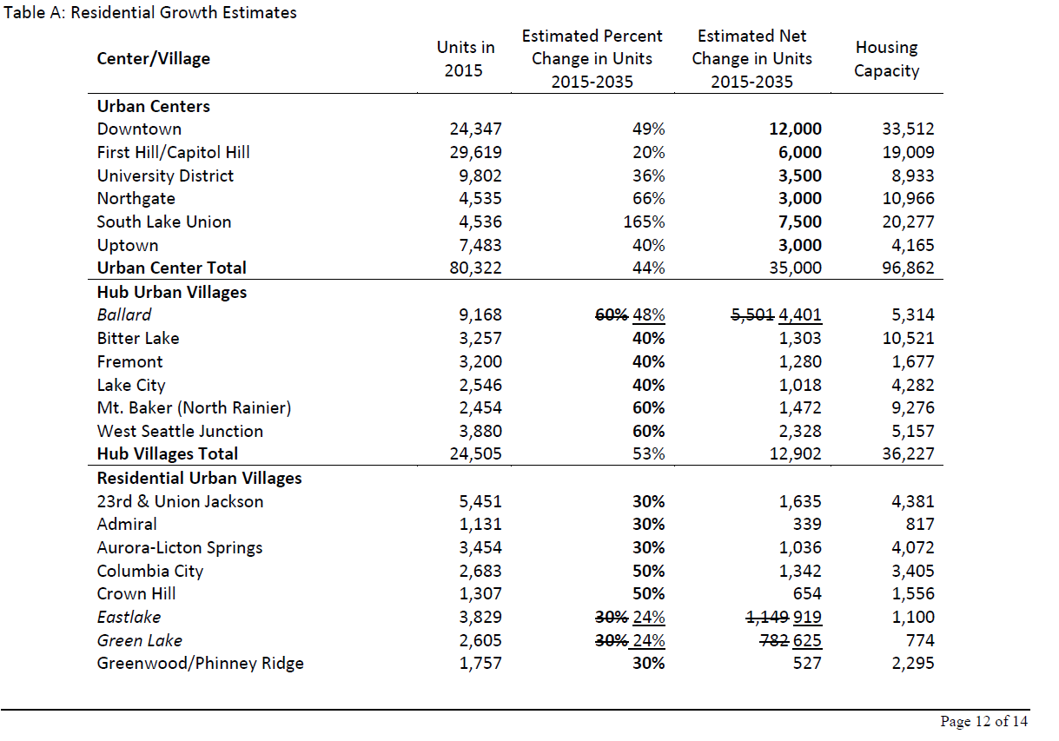
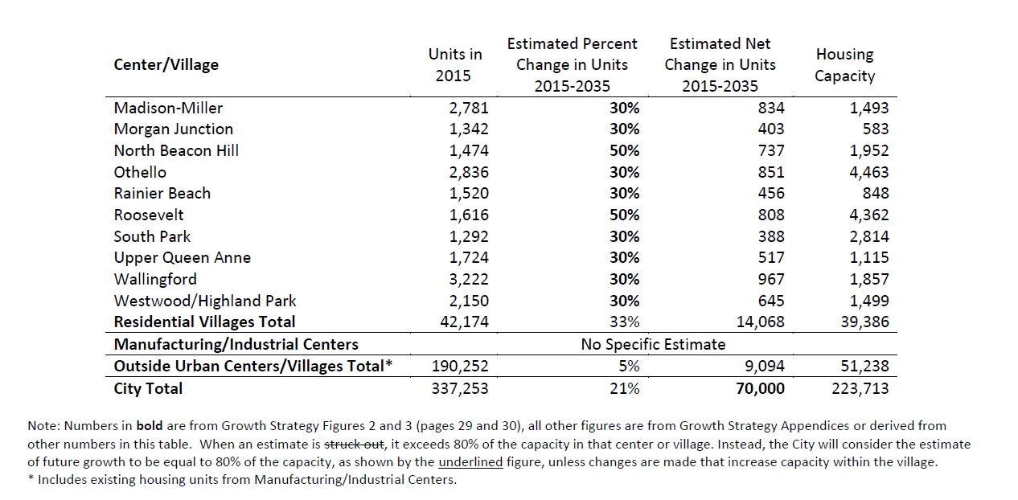
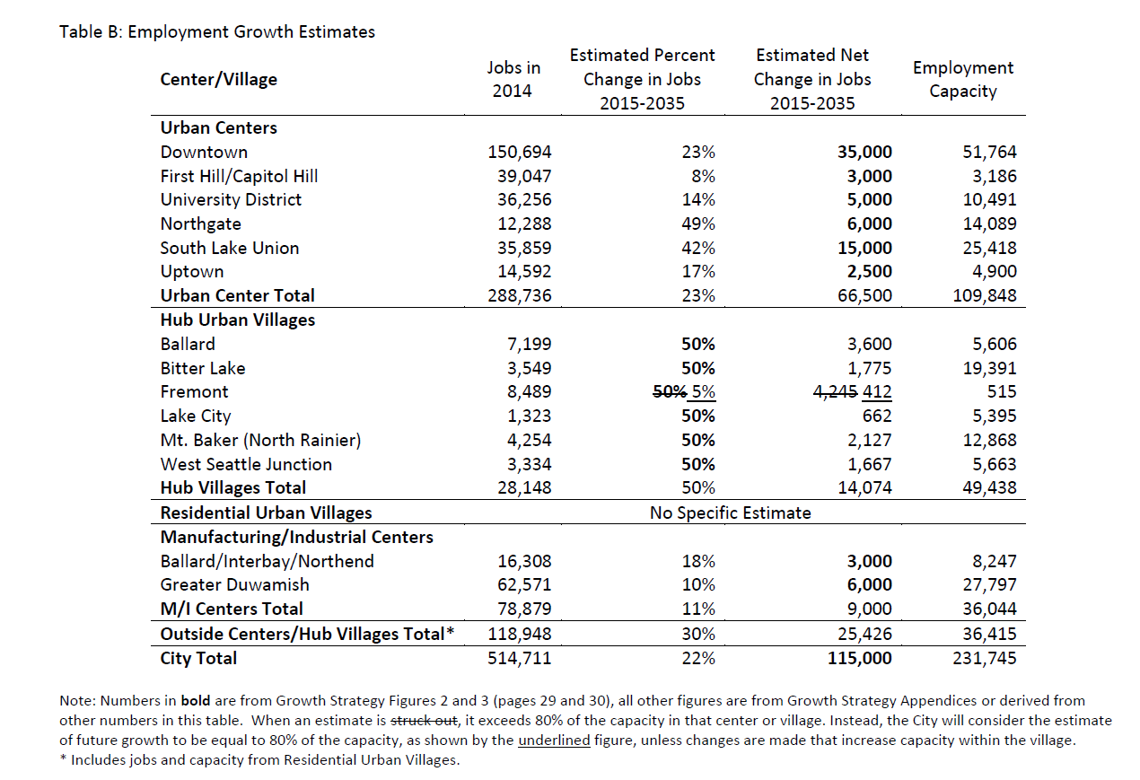

Restore policies concerning monitoring and reacting to unanticipated growth patterns.
A weakness in the current plan and the Mayor’s Plan is a lack of direction on how to respond to growth patterns that are not consistent with the estimates in the Comprehensive Plan. Several amendments were recommended for consideration in the 2014 annual amendment cycle, which Council requested be considered in this Seattle 2015 update. Instead the Mayor has proposed the following substitutions:
GS 1.4 Monitor development activity in urban centers and villages to track changes in the number of housing units, jobs, and population and evaluate whether development is consistent with this Plan.
GS 1.5 Use information collected about growth, along with other information, to make decisions for further planning or for making investments that will meet the needs of residents and businesses.
GS 1.6 Monitor development activity and other factors that will identify areas with high potential for displacement of marginalized populations and small businesses.
Central staff has advised that the Council not adopt specific policies to guide the timing and content of review, but instead use a “resolution of other legislative process” to provide “direction to the Executive about how monitoring and evaluation should take place.”
We disagree with this advice and point out that Resolution 30728 adopted 2004 (Resolution reestablish growth monitoring threshold criteria to identify growth conditions that trigger a neighborhood review as provided by the Comprehensive Plan.) has not been acted on by planning staff for lack of directed funding by Council. Therefore we recommend adoption in the Seattle 2035 Plan, the following policies:
Council should restore policy language UV44 and UV45 as worded prior to their removal in 2015, with modifications show by underline and add a policy directing compliance (and converted to numbering schema).
UV44 (2015) In order to monitor the effects of the urban village strategy: collect data, review, and report on growth and change in urban centers, urban villages, and manufacturing/ industrial centers at least every 3 years. Include in these reports factors such as: progress on implementing neighborhood plan approval and adoption matrices; changes in the numbers of jobs and housing units; housing costs, including net loss or gain of low-income and very low-income housing units; housing types; crime rates; transportation systems and their use; business types; public facilities; services; and open space, to the extent information is practically available. Collect and report on similar data for typical areas outside villages for comparison. Broadly communicate the results of monitoring efforts. Provide a Briefing to City Council by July of the year following the review in order to be used for consideration in the annual Budget cycle. Provide the results directly to the Neighborhood Plan Stewards on record with the Department of Neighborhoods.
Work with community members to identify appropriate responses to significant growth, lack of growth or changes, including: community-led activities; additional planning for, or re-prioritization of, City Programs or infrastructure improvements; partially or entirely updating a neighborhood plan; or working with other public agencies to address community goals.
UV45 (2015) Review situations where the rate of growth is significantly faster or slower than anticipated in the growth targets contained in Appendix UV-A or where other measures indicate significant changes in the center or village over an extended period of time. Evaluate the significance of the changes or the significance of lack of change with center or village residents, business owners, and other community stakeholders in light of the expectations underlying the neighborhood plan for the area, the actual level of growth, progress toward neighborhood plan implementation, and the relative maturity (level of mixed-use development, the pedestrian environment, infrastructure, and public facilities) of the area as an urban center or village
UVXX To ensure compliance with UV44 and UV45, the Council shall receive and consider a report, compiled by DPD and DON, that documents the impacts of growth in each Urban Village when approving capital and operating budget for all departments. These growth impact reports shall be available for public review prior to the start of the annual Council budget cycle.

PARKS LEVEL OF SERVICES
The current Comprehensive Plan has established measurable goals to ensure that that we have enough breathing room, recreational space, and nature close to our homes as the city grows. Seattle has recognized that there are major public health benefits in ensuring ample nearby green space.
The Mayor’s Recommended Plan would remove these metrics from the Comprehensive Plan and instead allow a future Parks plan to set the level of service. We strongly recommend leaving the current goals in place until there is a public process and council approval of any new level of service standard for parks and open space.
We also recommend that the definition of open space not be expanded to include privately owned property or public property where the city does not exert control of its use. Adequate open space is a very important concurrency, with implications for race and social justice and public health. We support the concept of shared open space with other institutions such as schools but those properties should not count toward meeting park and open space goals since they are temporary uses subject to the priority needs of the property owners.

We need to distinguish between parks and “green” transportation facilities.
The Parks policy below should be moved to the Transportation element because trails, green streets and boulevards are transportation facilities, not parks.
P 1.3 "Provide urban trails, green streets, and boulevards in public rights-of-way as recreation and transportation options and as ways to connect open spaces and parks to each other, to urban centers and villages, and to the regional open space system."
Other Concerns
Every HUB Urban Village should have a community center. We recommend strengthening P 2.4 by adding the bold underlined clause.
“Develop activities at community centers based on the specific needs of each community they serve and make them neighborhood focal points were people can enhance their individual health and wellbeing and strengthen a sense of community” and provide funding for replacement or new full service community center in Hub Urban Villages

TREE PRESERVATION, CANOPY AND DIVERSITY OF TREES IN THE CITY

Trees are in the way of the Mayor’s vision.
Several provision of the current LU39, 40 and 41 regarding tree retention, protection, and the indiscriminate removal or destruction of trees are jettisoned by the Mayor’s plan. Instead the Mayor proposes general language extolling the benefits of nature, an urban forest and the ecosystem. ENG 1, EN 1.1, 1.2, 1.3 and 1.4.
Recommendation: Retain current goals and policies protecting urban trees.
Restore specific protections from LU39/40 and adopt a strong tree ordinance that requires modification of designs to protect and preserve trees.

SURPLUS PROPERTY PRIORITIES
Concern: there is no overarching policy that provides guidance about how to balance the needs and prioritize between the different Elements.

Competition for surplus properties
There are several Elements within this Comp Plan which discuss use of surplus property for specific needs (see Housing, Parks & Open Space, Arts & Culture and Community Wellbeing). Policies need to better reconcile competition between use of surplus property for housing, open space, or other needs. For example:
- H 2.2 speaks of using surplus city-owned property for housing.
- AC 4.3 talks about making it available to artists and arts and cultural organizations.
- CW 2.7 talks about using it for local food production, processing, distribution and access.

Use of Surplus City-owned Property
We suggest that land not be divested from the city at all, and that leasing arrangements should be prioritized as the first use of a surplus property. If land must be sold, land of comparable value within the affected neighborhood must be purchased in its stead.

HOUSING

Single Family Policy Grand Bargain gamble.
Original drafts of the Comp Plan said “H 3.5 Consider allowing additional housing types that respect existing neighborhood character in single-family areas, particularly within or near urban centers and urban villages.” The final Draft released has moved to full implementation of transformation of Single Family zones inside Urban Villages. “H 3.5 Allow additional housing types in areas that are currently zoned for single-family development inside urban villages; respect general height and bulk development limits currently allowed while giving households access to transit hubs and the diversity of goods and services that those areas provide.”
This major shift was brought to council’s attention by Central Staff memo, June 29, 2016, but is not included in the final amendments under discussion. This is a presumption tied to the HALA Grand Bargain, where the Single Family zoned land inside Urban Villages is supposed to be up-zoned to multifamily in order to create more MHA-R land and subsequent generation of some percentage of affordable housing stock. But if the Grand Bargain collapses, this policy leaves in place that transformation of land without benefit. Policy H 3.5 should be restored to first draft language above.
Displacement and Preservation of Housing Stock
The desire to reduce displacement as a means of preserving housing affordability is a significant policy driver in the plan but there are no policies concerning the need to inventory and track what is called “naturally affordable housing.” Recent amendment to the MHA-R framework legislation go some way toward this but we still can’t answer the question “how much affordably housing do we have in Seattle and where is it? It will be hard to protect this valuable housing stock without better understanding of its nature and location. This includes single family homes that are shared housing now but also likely to be redeveloped into much more expensive units.
Polices to address cost of housing or cost of developer construction
The focus on housing policies appears to have shifted away from providing affordable housing to reducing the cost of construction. The current policy H7 - Periodically assess the effects of City policies and regulations on housing development costs and overall housing affordability, considering the balance between housing affordability and other objectives such as environmental quality, urban design quality, maintenance of neighborhood character and protection of public health, safety and welfare is being replaced with : H 4.8 Explore ways to reduce housing-development costs.
Throughout the Plan, there is confusion over whether the goal is to reduce the cost of construction or to reduce the cost of rent. Reducing construction cost does not substitute for broader scope of the current policy. We recommend retaining the current policy HG2 “Maintain housing affordability over the life of this Plan.”
Group related policies about housing preservation
Policies dealing with preservation should be grouped together in a Preservation section of the Housing element. HG2, H4.5, H5.1, H5.2, H5.4, H5.8, H5.10 and H5.14 should be included.
Seniors need to be able to remain in their own homes and neighborhoods. Retain HG6 from the current comprehensive plan: “Encourage and support accessible design and housing strategies that provide seniors the opportunity to remain in their own neighborhood as their housing needs change.”
When housing is demolished, the new housing built in its place does not serve the same function of what was lost. This is particularly true for family housing (with 3 or more bedrooms). Preservation of family housing should be promoted.

References

seattle.legistar.com/gateway.aspx?M=F&ID=dfb46b38-3875-4922-8c4b-9478949edc3b.pdf
seattle.legistar.com/gateway.aspx?M=F&ID=a3a89c25-891c-468d-ae7e-bb9d39b18d83.docx
http://www.kcmetrovision.org/view-plan/
seattle.legistar.com/gateway.aspx?M=F&ID=53fb7034-627b-4248-a672-6e2e1cbd8843.pdf
seattle.legistar.com/gateway.aspx?M=F&ID=9ee289be-00de-467a-a98a-5d1feaee33bd.docx

